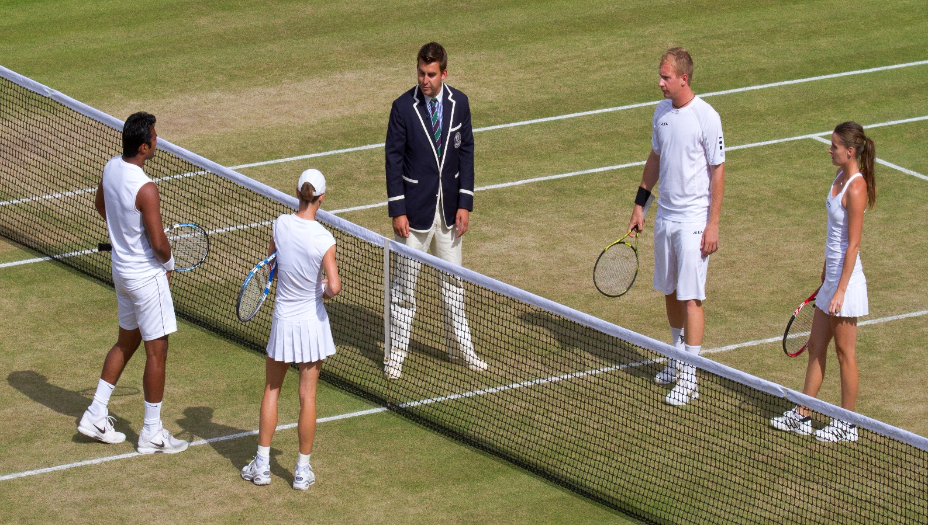

Nittedal Tennis Club Organizes

**a Family Double Tournament**

**The 23th of October**

**From 14h30**



Come and join the team to play our 1st family double tournament allowed to all ages and all levels (level groups will be set up)

**Program:**

* Short coaching to play double
* Matches with tie-break format
* Video shooting & viewing
* Drinks

**Come by Numerous! ;))**